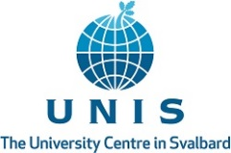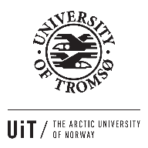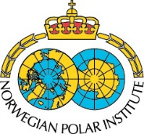

Summer school announcement

The Arctic Ocean and the marginal ice zone (MIZ).
Interdisciplinary research, management practices and policy developments.

An interdisciplinary PhD and Post-Doc summer school in Longyearbyen, Svalbard

Hosted by the Norwegian Scientific Academy for Polar Research (NVP), in cooperation with the University Centre in Svalbard (UNIS), UiT – the Arctic University of Norway, the Nord University, the Norwegian Polar Institute (NPI), Akvaplan-niva, the Nansen Environmental and Remote Sensing Center (NERSC), and the Russian Geographical Society (RGS).

- Venue: The Norwegian Scientific Academy for Polar Research (NVP), c/o UNIS, Longyearbyen, Svalbard.

- Time: 31st July – 5th August 2017.

The consequences of climate change are particularly evident in the Arctic. In recent years, we have witnessed significant changes and reductions in Arctic sea ice distribution and volume. Seized as an opportunity, plans are being made for expansion of economic activities such as shipping, fisheries, petroleum extraction and deep-sea mining. Changes in ice cover and distribution will also have consequences for national and international management regimes.

This new situation represents challenges for scientists, managers and policy makers and for the private sector. More and better communication between different parts is required, and the best way forward needs to be further developed for sound management and sustainable use of the Arctic oceans’ vast renewable and non-renewable resources.

The international summer school 2017 will have a multi- and cross-disciplinary thematic approach to meet challenges and opportunities related to governance of the Arctic Ocean’s marginal ice zone. Scientists and experts from Norway and abroad will contribute to the summer school 2017 with lectures and with interactive student and teacher sessions. The participating students will be challenged to start drafting a peer-reviewed publication for an international journal.

The summer school’s main target group is PhD students and Post-docs. In some cases, students with a MSc degree or equivalent and with special professional qualifications, for example from the private sector industry or from other relevant institutions, may also participate. The relevance of current studies, including personal motivation and relevant experiences are important selection criteria.

The participants must cover their own transport to Longyearbyen, Svalbard and return and accommodation during transit. Non-Norwegian participants must bring their passports for travel to Svalbard. Participation at the summer school is free and the organizers will cover accommodation, lunch and dinners and excursions during the scheduled stay in Svalbard.

Up to 30 students from different countries and with different expertise and experience will be selected. Applications shall include a CV and a letter which describes a rationale and justification for the application. A tentative title of a poster to present current studies should be included in the application.

Applications are sent to the Norwegian Scientific Academy for Polar Research (NVP), att. Office Manager Jorge Kristiansen e-mail post@polar-academy.com with the subject: “Application summer school 2017”.

Application deadline is Monday 8 may 2017. The selected candidates will be notified by the end of May 2017.

For additional information, see NVP’s web-page http://www.polar-academy.com/.
Contact for the summer school 2017 is NVP’s Office Manager Jorge Kristiansen, e-mail post@polar-academy.com, telephone +47 79026408

