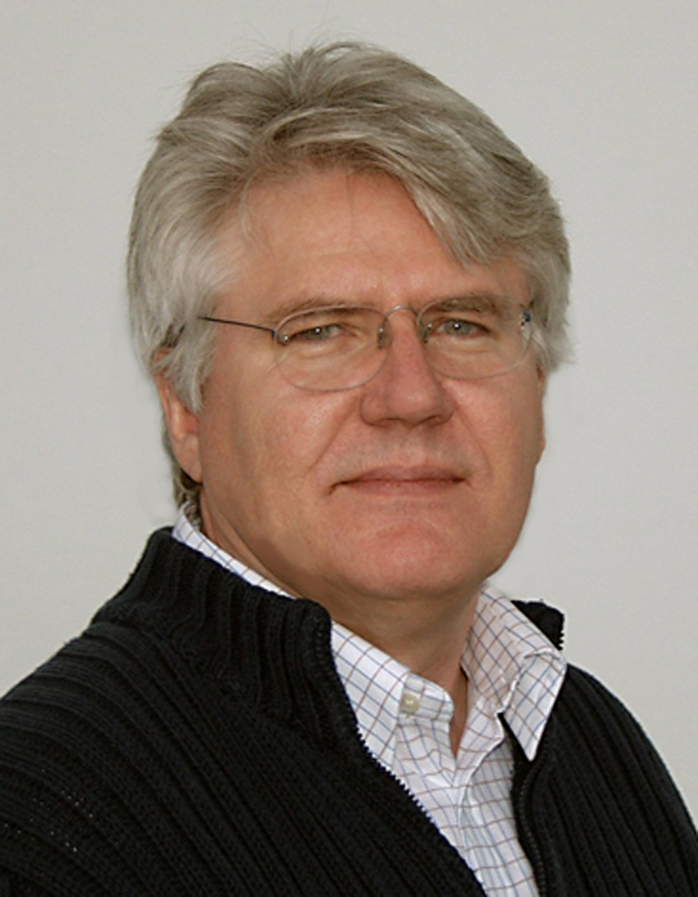

Short description regards environmental chemicals
March 2012

Allan Astrup Jensen is PhD organic chemistry from Copenhagen University in 1969. He recently became Research Director and CEO at the Nordic Institute of Product Sustainability, Environmental Chemistry and Toxicology, Denmark. He has about 40 years of professional experience in environmental chemistry and toxicology from employment in universities, not-for-profit institutes and government.
His areas of expertise and interests in chemicals and the environment are broad, and the focus is on the chemical more than the area/compartment. He was responsible for the first source/flow analysis in Denmark of dioxin, PCB/PCT, CFCs, cadmium, and mercury. He still works with various aspects of these and other chemicals (lead, PAH, brominated flame retardants, polyfluorinated compounds, greenhouse gasses, chemical carcinogens). He has made pioneering work with studying chemical contamination of human milk and tissues. He has also been involved in green chemistry and life cycle assessment of chemicals.
His present main interests are PFCs, HBCDD, and PCB in buildings and indoor environment.
He has had scientific and other relations with international organisations such as the European Commission, the European Environment Agency, OECD, WHO/IPCS, WHO/EURO, UNEP DTIE, UNEP Chemicals, SAICM, the Stockholm Convention, the OSPAR Convention, the Helsinki Convention, Nordforsk and Nordic Councils of Ministers.
He was funding chairman of the Danish Society for Environmental Chemistry from 1984-1987 and chairman of FECS/EuCheMS Division on Chemistry and the Environment from 1996-2003. He was organizer of the 6th FECS Conference on Chemistry and the Environment (about air pollution) in Copenhagen, 26-28 August 1998. In addition he was main organizer for the 5th SETAC-Europe Congress in Copenhagen, 25-28 June 1995, with 850 participants. He was recently (2010) co-initiator of a Nordic Network on Fluorinated Compounds in the Environment.
In 2001 he received the Environmental Chemistry Award of the Italian Chemical Society and in 2008 the prestigious EuCheMS Service Award.

